* Report view

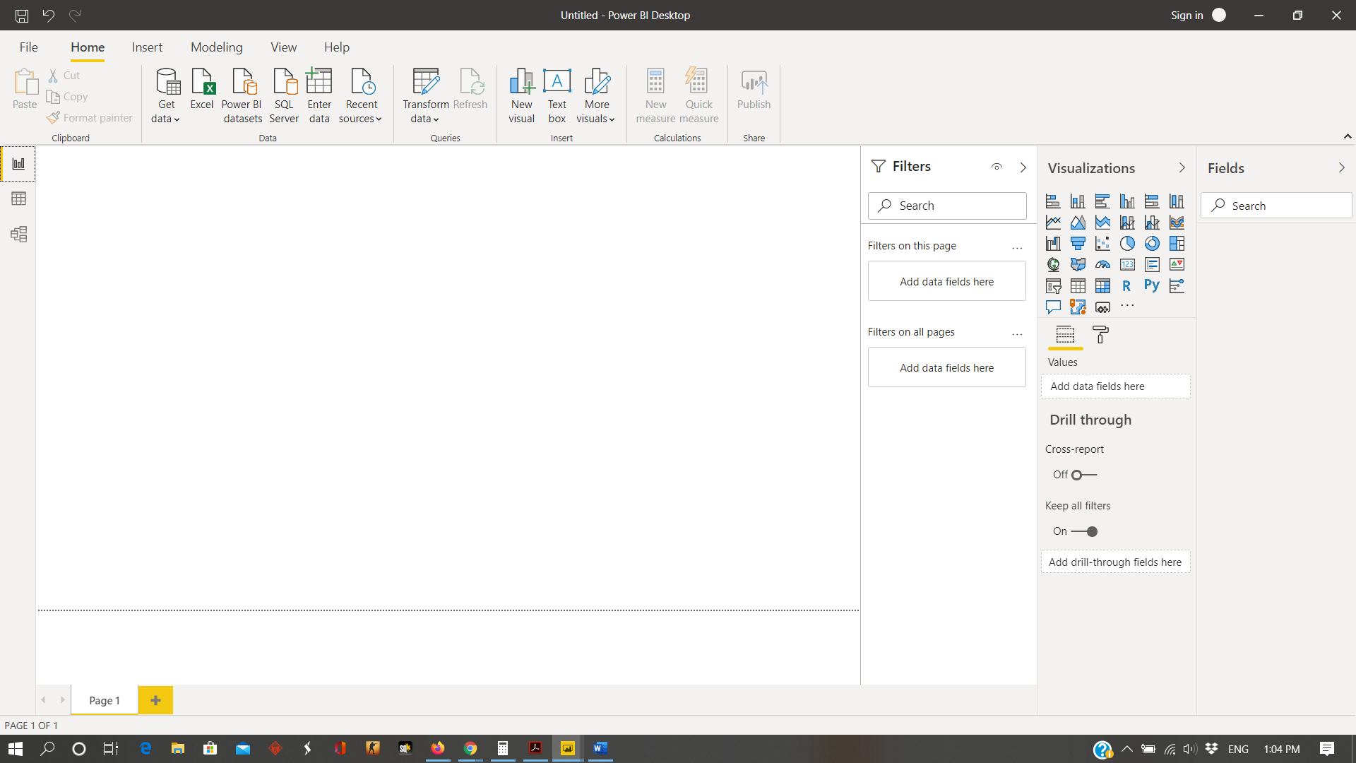

* Data View

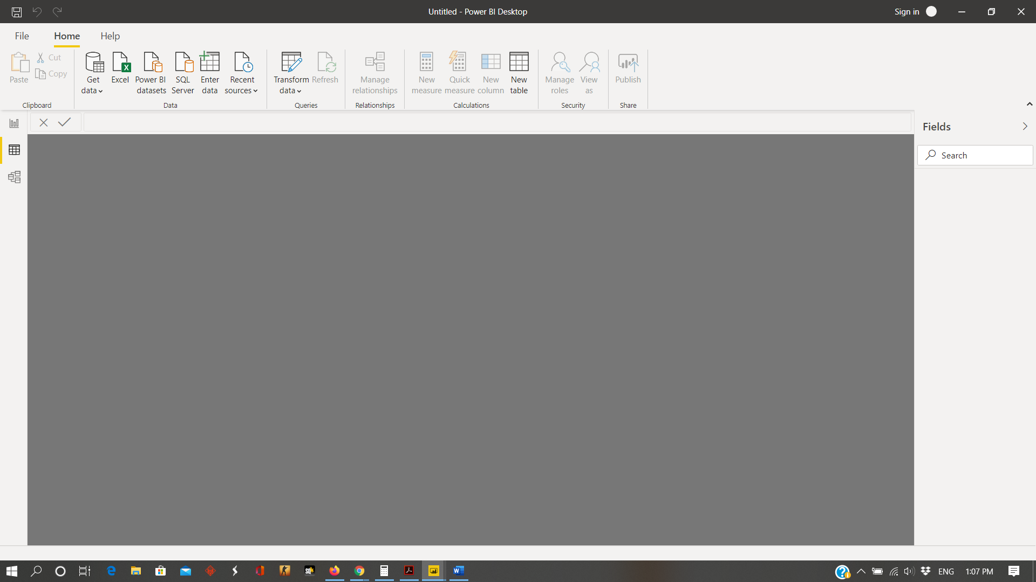

* Model View



* Power Query Editor

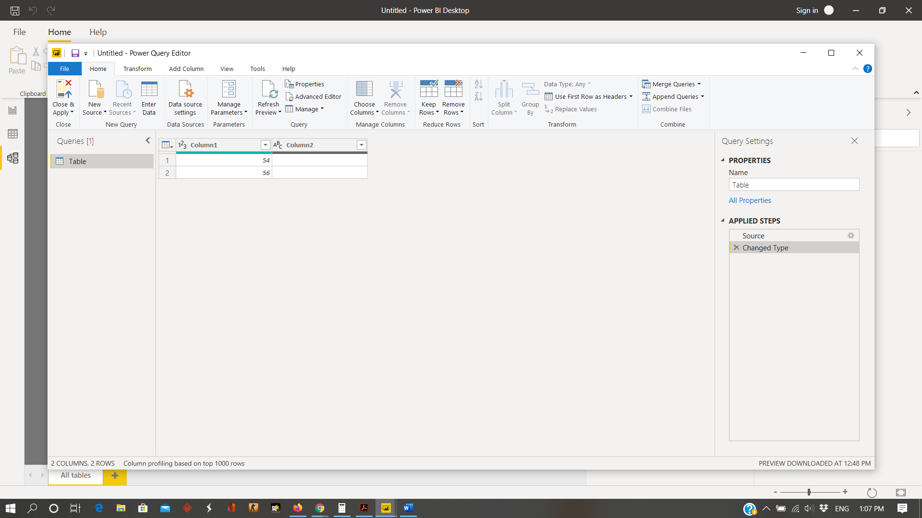

* Advance Editor

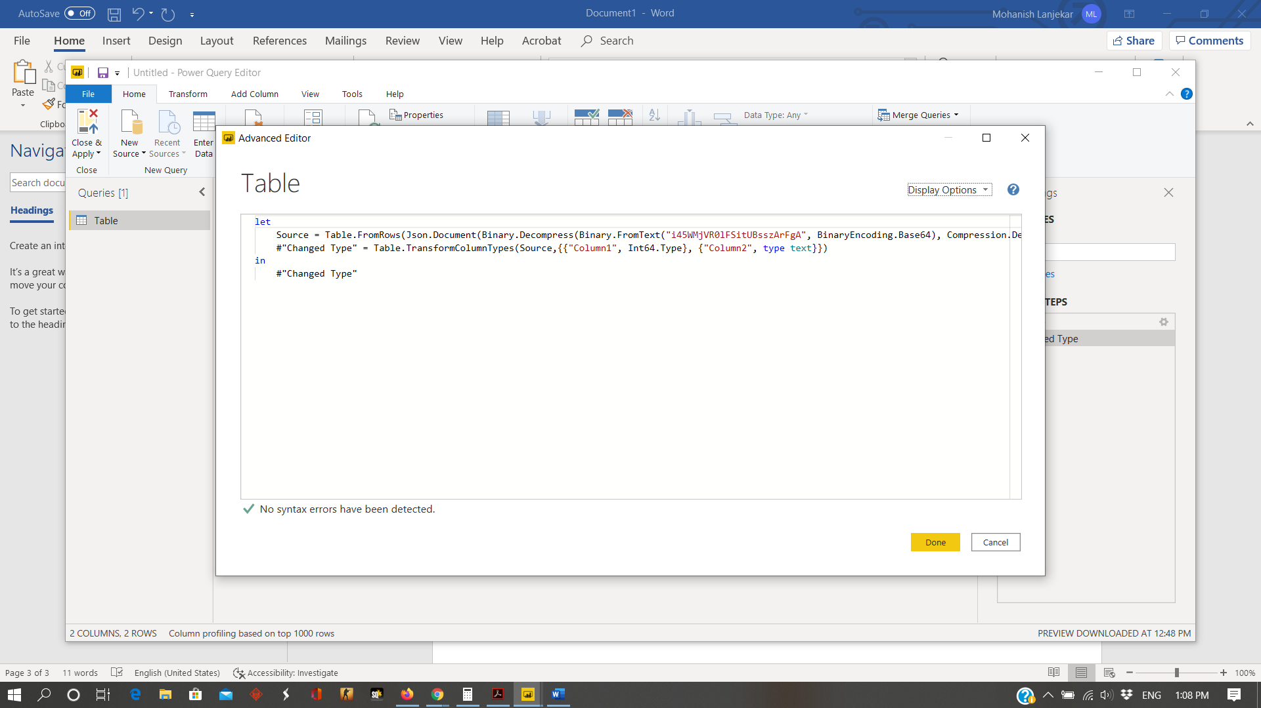

1. Prepare a document with details of the following along with their price

Power BI Desktop

Power BI PRO

Power BI Premium

ANS:-

Power BI Desktop is the free version of Power BI. There are many functions that Microsoft has added in free version like :-

* Auto-detect that finds and creates data relationships between tables and formats
* Python support
* Connect and import data from over 70 cloud-based and on-premises sources

But there are also some limitations like you can’t share created reports with non-Power BI Pro users, no app workspaces, no API embedding, no email subscriptions etc.

Power BI Pro is the full version of Power BI with the ability to use Power BI for both building dashboards and reports and unlimited viewing, sharing and consumption of your created reports (this is not possible with desktop version.) Price :- $9.99 per month per user

Power BI Premium is the most expensive tier of Power BI currently available. It is not an individual license; you’re buying them in bulk to allow a large number of your users to use Power BI to view reports. All of your content is stored in Premium and can then be viewed by as many users in your organization as you want, without additional per-user costs.

Price:- $4,995 monthly per dedicated cloud compute and storage resource with annual subscription